## Capstone Project: Excel

Data set: [Indian Startups Funding](https://docs.google.com/spreadsheets/d/18OpUWH9L2nNGakeW9m_MJ15ubzb9MymDKhKxTLiGHRg/edit?usp=sharing)

Most of the data headers are self-explanatory

Basic Formatting:

1. Increase the column widths to appropriate sizes so that they are readable
2. Format the header row in a suitable color
3. Align the header content in the middle of the cell
4. Bold the content in the headers
5. Draw the borders

Report Making:

1. Freeze the header row
2. Hide unwanted columns

Functions:

1. Add a new column and create a new segment which is a combination of Headquarters-Sector EX: Banglore-OTT
2. Add a new column named “Decade” and convert all the years into decades EX: 1960 - 1969 will be 196
3. Add a new column named “Category” and Print
   1. if the Amount is > 4500000 and the Headquarters is based in any of these cities Bangalore, Pune, Mumbai, or Delhi print as CAT A
   2. if the Amount > 450000 and Headquarters is based in any of these cities Gurugram, Surat, Jaipur, Hyderabad print as CAT B
   3. Else CAT C
4. Add a new column and name it Tier and assign the data according to the Headquarters from sheet 2

Conditional formatting:

1. Find the duplicates in the company column
2. Highlight all series D funding with different color

Sorting and filtering:

1. Sort the decade in ascending order within the decade sort the Tier in ascending order and within the Tier sort the Amount in descending order

The report should look like this:

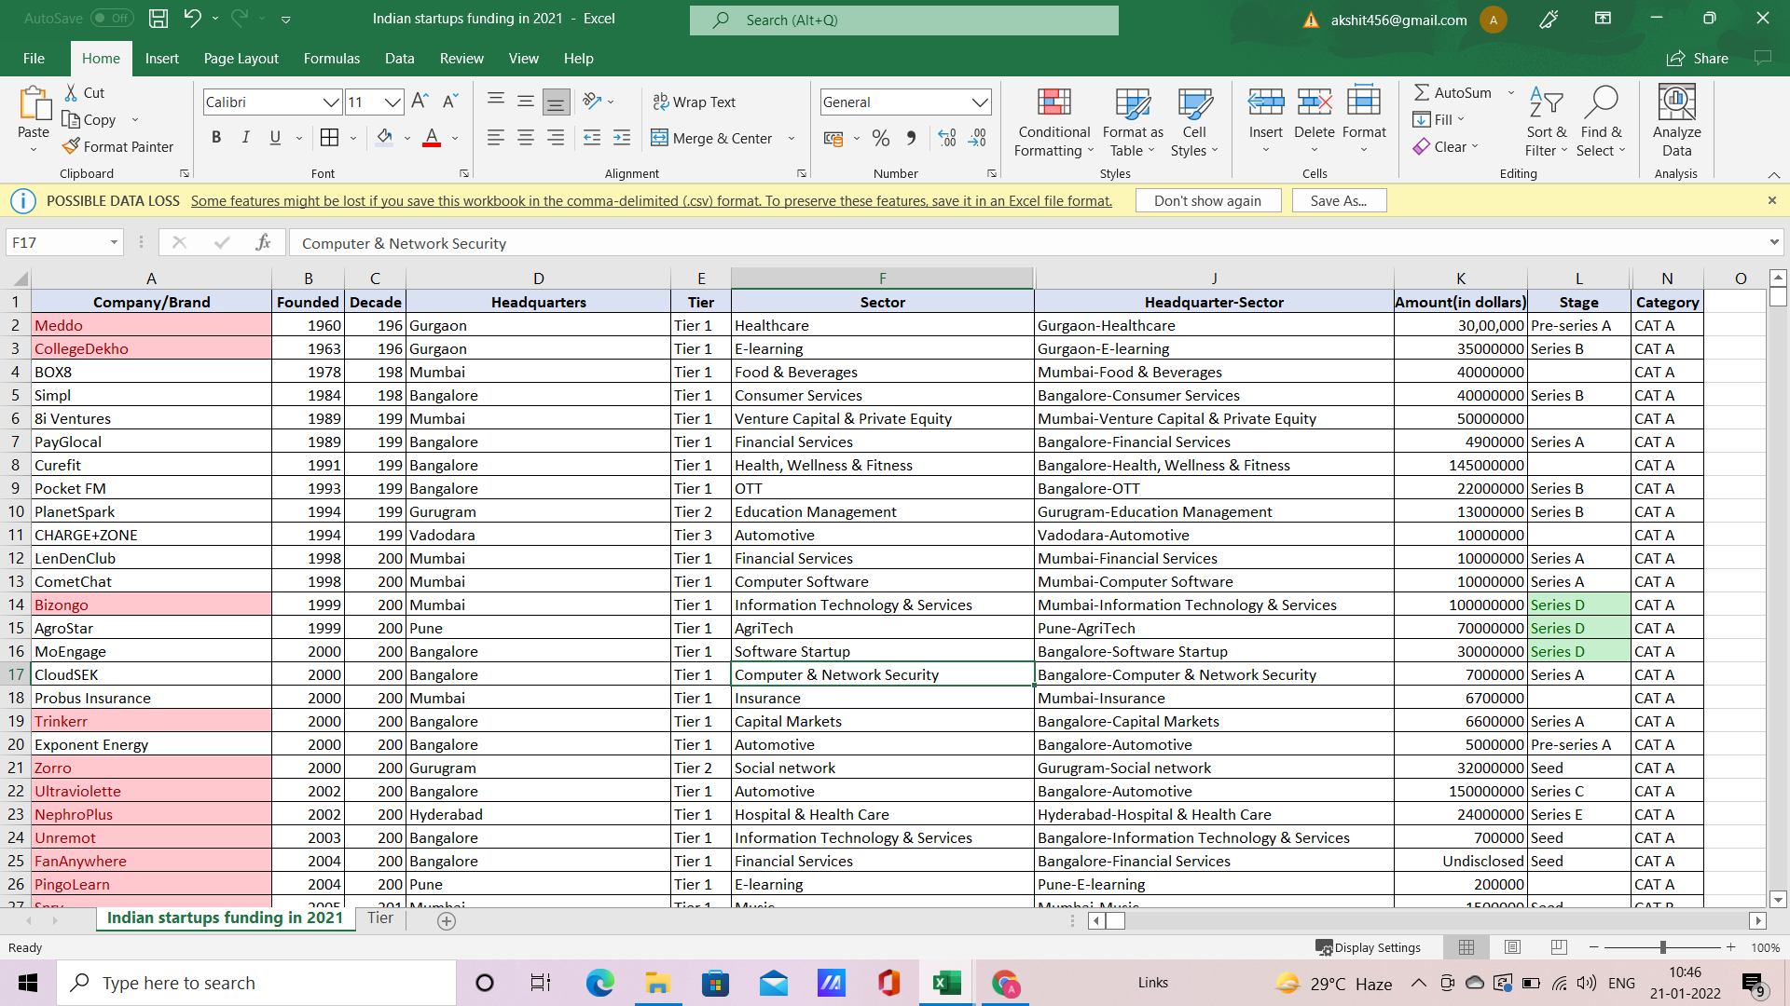

Pivot tables:

1. Create a table for Companies and their total count of funding and then display the sum of the amount as their table values
2. Create a Row table for Decade and Tier with the Total amount as their table values
3. Create a table for Headquarters and Series with the Average amount

Charts and Graphs:

1. Insert graphs for all the 3 charts that you created and
2. Do required modifications